CS-340-T5534 Client/Server Development 23EW5

5-2 Assignment: Client-Side Authentication

Jacob Simmons, 04 June 2023

* **Unique Dashboard Identifier**

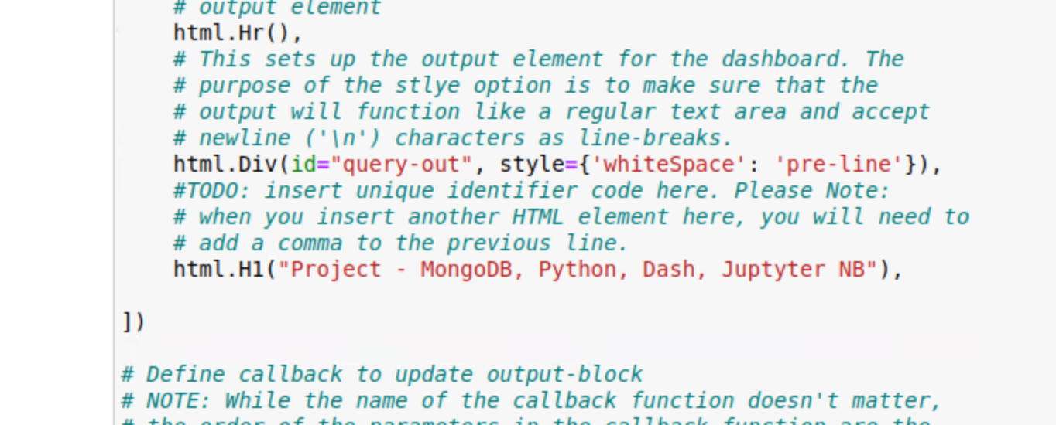

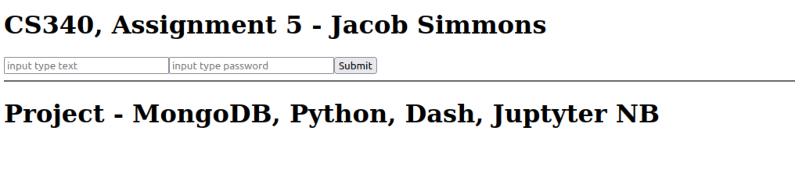

* **Import CRUD Python Module**

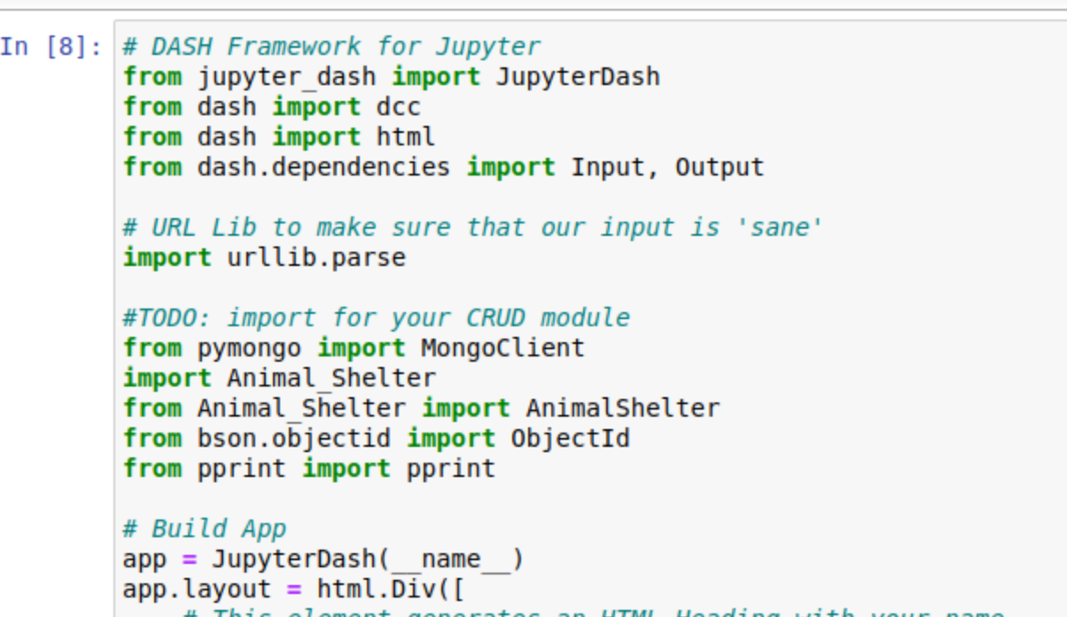

* **Callback Routine Functionality**

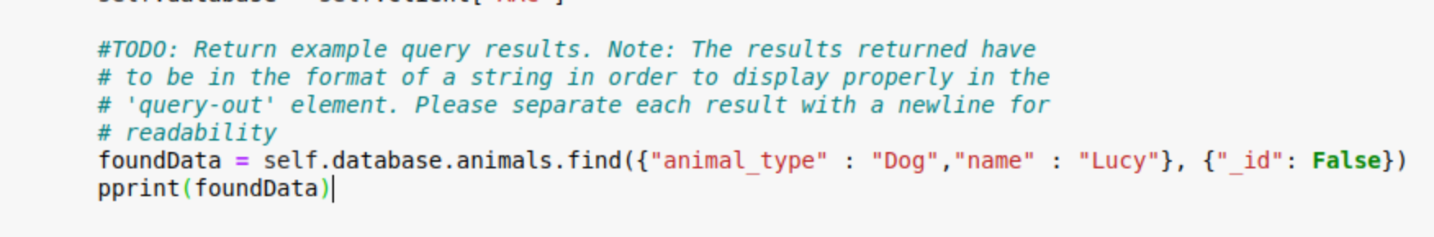

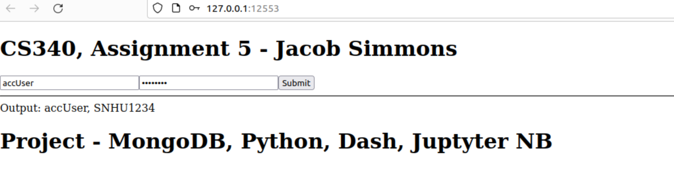

**References**

None